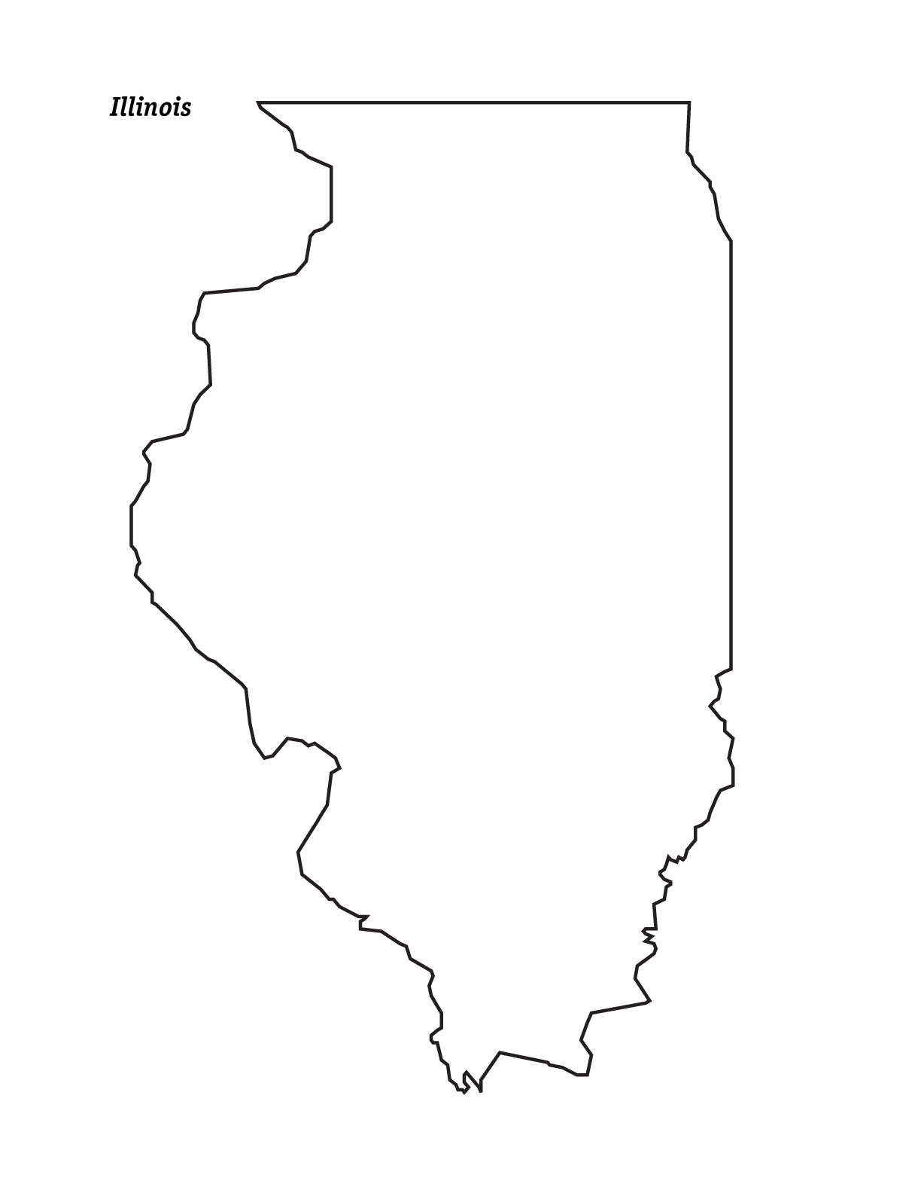

Method of districting used ____________

**http://www.mrdaymont.com/gerrymandering/gerrymandering_illinois_map.docx**

**1.** Make sure you have   
30 pieces of candy

(15 **Color A**, 15 **Color B**)

**2.** Draw 6 Equal Sized  
Districts (5 Votes Each)   
giving the *Majority* (at least 4 of 6 districts) to the **Color A candies**

**3.** Draw 6 Equal Sized Districts   
(5 Votes Each) giving the *Majority* (at least 4 of 6 districts) to the **Color B Candies**

**4.** For each attempt, write which method you used (packing or dilution) for both sets of District Lines.

**Gerrymandering Worksheet**

Name:____________________



Method of districting used ____________

**http://www.mrdaymont.com/gerrymandering/gerrymandering_illinois_map.docx**

**1.** Make sure you have   
30 pieces of candy

(15 **Color A**, 15 **Color B**)

**2.** Draw 6 Equal Sized  
Districts (5 Votes Each)   
giving the *Majority* (at least 4 of 6 districts) to the **Color A candies**

**3.** Draw 6 Equal Sized Districts   
(5 Votes Each) giving the *Majority* (at least 4 of 6 districts) to the **Color B Candies**

**4.** For each attempt, write which method you used (packing or dilution) for both sets of District Lines.

**Gerrymandering Worksheet**

Name:____________________